

WORKSHOP 4 – SUBMISSION REQUIRED (20%)
DATABASE DESIGN: LOGICAL DATABASE DESIGN

Note: Read ALL the instruction before begin, it may saves you lots of time.
In this workshop, you will gain solid understanding of the relational data model including the general properties of relations, integrity constraints, and the characteristics of well-structured relations. You will also filled with a firm grasp on the principles of functional dependencies, determinants, and related concepts of normalization. You are expected to complete this assessment in a group
Due Date: Within 24 hours, 5% deduction applied for every 6 hours late.
CASE STUDY:
Having reviewed your conceptual models (from Workshop 2 and 3) with the appropriate stakeholders and gaining their approval, you are now ready to move to the next phase of the project, logical design. Your next deliverable is the creation of a relational schema.
Case Study Extracted from:
Hoffer, Jeff, Ramesh Venkataraman, Heikki Topi. Modern Database Management, Global
Edition, 13th Edition. Pearson (Intl)
TASKS
You are to work with your group members to complete these tasks.
- Map the EER diagram you developed in Workshop 3, Task 1 to a relational schema using the techniques described in chapter 4. Be sure to appropriately identify the primary and foreign keys as well as clearly state referential integrity constraints. (10%)
- Analyze and document the functional dependencies in each relation identified in Task 1 above. If any relation is not in 3NF, decompose it into 3NF, using the steps described chapter 4. Revise your relational schema accordingly. (10%)
- Include both your relational schema and normalized relational schema as well as finalized ER Diagram into a word document. Attached a cover page with your group members name and submit to Blackboard submission link for grading.
Database Design & Modelling Page 1 of 1 SG LAB ITGD2003 V0Hea10 Copyright © PSB Academy

TASK 1 Relational Schema & EER Development

Relational Schema (Before normalization)
Relation Name | Attributes (Primary Key Underlined) | Dependency Issues Found
EMPLOYEE_TOTAL | EmployeeID, EmployeeName, Phone, HireDate, LicenseNumber, SupportLevel, Certification | Transitive Dependencies: Non-drivers have empty license fields; attributes depend on the type of employee, not just the ID.
CUSTOMER_ORDER | ShipmentID, ShipmentDate, CustomerID, CustomerName, CustomerAddress | Partial Dependencies: CustomerName depends only on CustomerID, not the ShipmentID.
PRODUCT_VENDOR | ProductID, VendorID, ProductDesc, ProductCost, VendorName, VendorPhone | Partial Dependencies: VendorName depends only on VendorID; ProductDesc depends only on ProductID.

EER Diagram Development

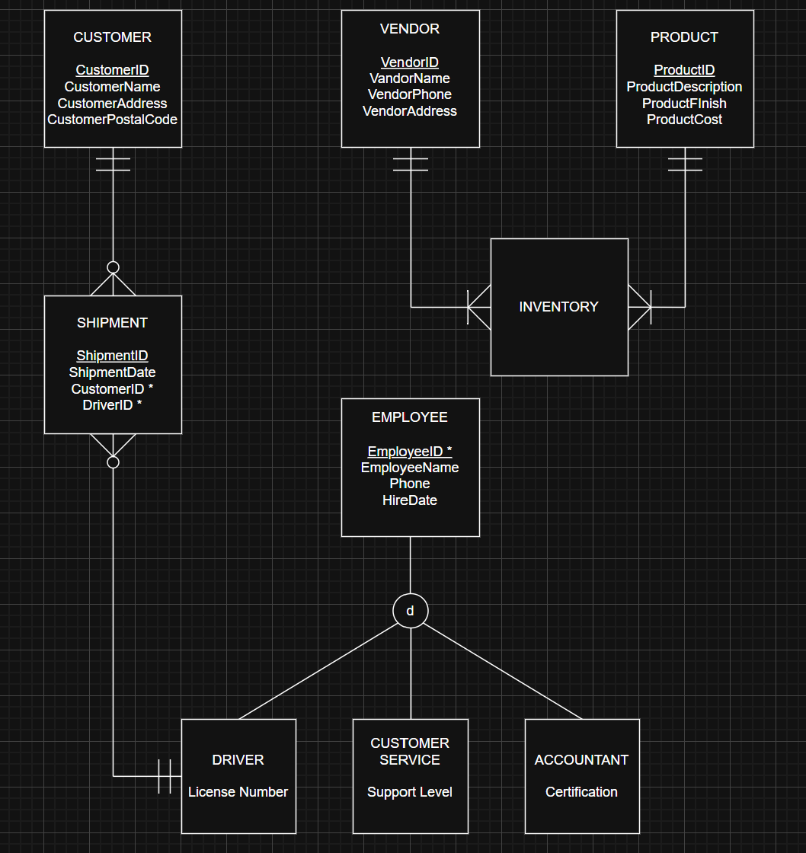

Entities and Attributes
- CUSTOMER: CustomerID, CustomerName, CustomerAddress, CustomerPostalCode
- VENDOR: VendorID, VendorName, VendorPhone, VendorAddress
- PRODUCT: ProductID, ProductDescription, ProductFinish, ProductCost
- EMPLOYEE (Supertype): EmployeeID*, EmployeeName, Phone, HireDate
- SHIPMENT: ShipmentID, ShipmentDate, CustomerID*, DriverID*
- INVENTORY (Associative Entity): VendorID, ProductID
- SUBTYPES:
- DRIVER: EmployeeID, LicenseNumber
- CUSTOMER SERVICE: EmployeeID, SupportLevel
- ACCOUNTANT: EmployeeID, Certification

Primary and Foreign Key Identification
Table | Primary Key (PK) | Foreign Key (FK)
CUSTOMER | CustomerID | -
VENDOR | VendorID | -
PRODUCT | ProductID | -
INVENTORY | VendorID + ProductID (Composite) | VendorID, ProductID
EMPLOYEE | EmployeeID | -
DRIVER | EmployeeID | EmployeeID
ACCOUNTANT | EmployeeID | EmployeeID
CUSTOMER_SERVICE | EmployeeID | EmployeeID
SHIPMENT | ShipmentID | CustomerID, DriverID

Relationships and Cardinalities

1. CUSTOMER to SHIPMENT (1:M):
- Cardinality: A shipment must belong to exactly one customer (Mandatory One), but a customer may have zero shipments or many (Optional Many).
2. DRIVER TO SHIPMENT (1: M):
- Cardinality: A shipment needs to have a single assigned driver (Mandatory One), but a driver may be assigned to multiple shipments (Optional Many).

3. VENDOR to INVENTORY (1:M):
- Cardinality: While each inventory record identifies a single vendor (Mandatory One), a single vendor may be linked to numerous inventory records (Mandatory Many).
4. PRODUCT to INVENTORY (1:M):
- Cardinality: Each inventory record identifies a single Product (Mandatory One), but a single Product may appear in multiple inventory records (Mandatory Many).
5. Supertype/Subtype Employee Hierarchy:
- One-to-one (1:1) is the relationship.
- Rule: Using a Disjoint (d) constraint, an employee is specialized into a single role (driver, customer service, or accountant).

Task 2: Functional Dependencies & Normalization
Functional Dependencies

- CUSTOMER: CustomerID → CustomerName, CustomerAddress, CustomerPostalCode
- VENDOR: VendorID → VendorName, VendorPhone, VendorAddress
- PRODUCT: ProductID → ProductDescription, ProductFinish, ProductCost
- EMPLOYEE: EmployeeID → EmployeeName, Phone, HireDate
- SHIPMENT: ShipmentID → ShipmentDate, CustomerID, DriverID
- INVENTORY: VendorID, ProductID (No non-key attributes)
- Subtype FDs:
- DRIVER: EmployeeID → LicenseNumber
- ACCOUNTANT: AEmployeeID → Certification
- CUSTOMER_SERVICE: CEmployeeID → SupportLevel

Analysis of Third Normal Form (3NF)

To establish that our design is in third normal form, we evaluate it against the three steps of normalization:
- All characteristics are atomic in the First Normal Form (1NF), which does not contain any lists or groupings of data. Our design fulfilled 1NF because each field has just one value.

- The Second Normal Form (2NF) has no partial dependencies. As a result, every non-key attribute depends on the entire main key. For example, in the INVENTORY database, no attribute depends on a single piece of the composite key.

- The Third Normal Form (3NF) does not have any transitive dependence concerns. One non-key attribute cannot be used to determine another. For example, the LicenseNumber is directly connected to the EmployeeID by decomposing the employee position into subtypes (like DRIVER). If we had kept LicenseNumber in the main EMPLOYEE database, it would be a transitive dependency because certain employees do not possess licenses.

Final Normalized Relational Schema

- CUSTOMER (CustomerID, CustomerName, CustomerAddress, CustomerPostalCode)
- VENDOR (VendorID, VendorName, VendorPhone, VendorAddress)
- PRODUCT (ProductID, ProductDescription, ProductFinish, ProductCost)
- EMPLOYEE (EmployeeID, EmployeeName, Phone, HireDate)
- SHIPMENT (ShipmentID, ShipmentDate, CustomerID*, DriverID*)
- INVENTORY (VendorID*, ProductID*)
- DRIVER (EmployeeID*, LicenseNumber)
- ACCOUNTANT (EmployeeID*, Certification)
- CUSTOMER_SERVICE (EmployeeID*, SupportLevel)

CUSTOMER
CustomerID | CustomerName | CustomerAddress | CustomerPostalCode

VENDOR
VendorID | VendorName | VendorPhone | VendorAddress

PRODUCT
ProductID | ProductDescription | ProductFinish | ProductCost

INVENTORY
VendorID | ProductID

DRIVER (Subtype)
EmployeeID * | LicenseNumber

EMPLOYEE (Supertype)
EmployeeID * | EmployeeName | Phone | HireDate

CUSTOMER_SERVICE (Subtype)
EmployeeID * | SupportLevel

ACCOUNTANT (Subtype)
EmployeeID * | Certification

SHIPMENT
ShipmentID | ShipmentDate | CustomerID * | DriverID *

Referential Integrity (RI) Constraints

1. Business & Inventory Constraints
- The VendorID in the INVENTORY table must exist in the VendorID column of the VENDOR table.
- The ProductID in the INVENTORY table must exist in the ProductID column of the PRODUCT table.
- The CustomerID in the SHIPMENT table must exist in the CustomerID column of the CUSTOMER table.
- The VendorID and ProductID in INVENTORY must exist in the VENDOR and PRODUCT tables respectively.

2. Employee Hierarchy (Supertype/Subtype) Constraints
- The EmployeeID in the DRIVER table must exist in the EmployeeID column of the EMPLOYEE table.
- The EmployeeID in the ACCOUNTANT table must exist in the EmployeeID column of the EMPLOYEE table.
- The EmployeeID in the CUSTOMER_SERVICE table must exist in the EmployeeID column of the EMPLOYEE table.

3. Shipment Personnel Constraints
- The DriverID in the SHIPMENT table must exist in the EmployeeID column of the DRIVER table.

